**Bucket Versioning**

1. Navigate to the **Services** menu at the top and click on **S3** in the **Storage** section.
2. On the S3 dashboard, click on **Create bucket**button and fill in the bucket details.
3. Select Region as N.Verginia to create an S3 bucket.

* Bucket type Select : **General purpose**
* Bucket name**:**Enter ***whizlabs-<RANDOM_NUMBER>***
* **Note:** S3 bucket names are globally unique, choose an available name.

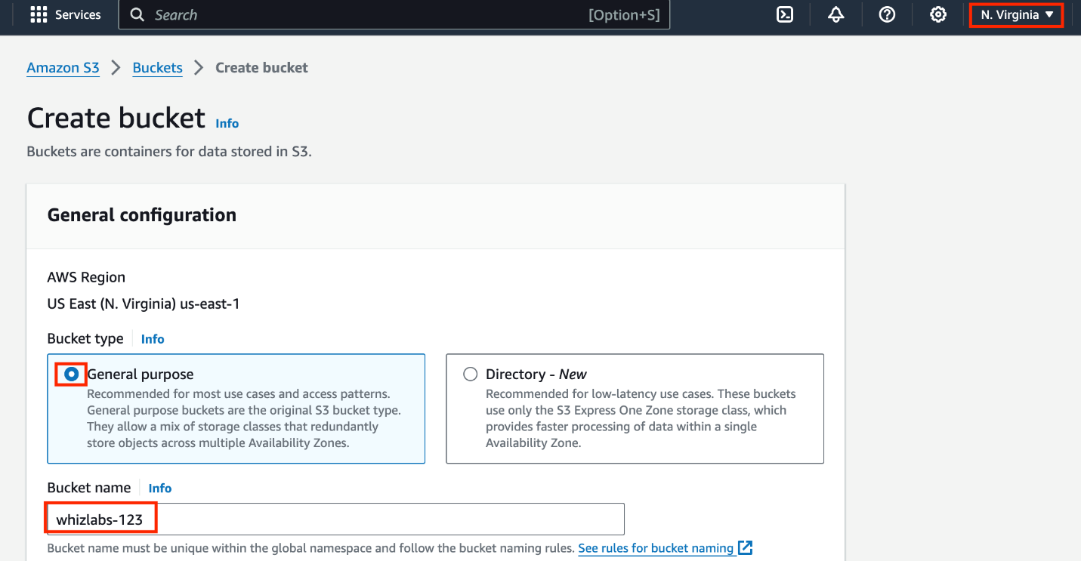

* Object ownership: Select **ACLs disabled (recommended)** option
* Uncheck the option**, Block all public access,**and check the **acknowledge** option.

* Leave other settings as **default**.
* Click on **Create bucket**button.

       4. Your S3 Bucket is now created.

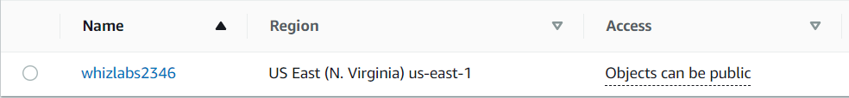

Task 3: Enable Versioning on the S3 bucket

1. Click on your bucket name **whizlabs2346.**
2. Click on **Properties**tab.

      3. Under **Bucket Versioning**, click on **Edit**button.

      4. Bucket Versioning : Select **Enable** radio button.

      5. Now Click on the **Save changes** button.

      6. Now Bucket versioning is enabled.

Task 4: Upload an object and make the bucket public

1. Click on the **Objects**tab.
2. In the Overview, you can see the following message:
   * **This bucket is empty. Upload new objects to get started.**

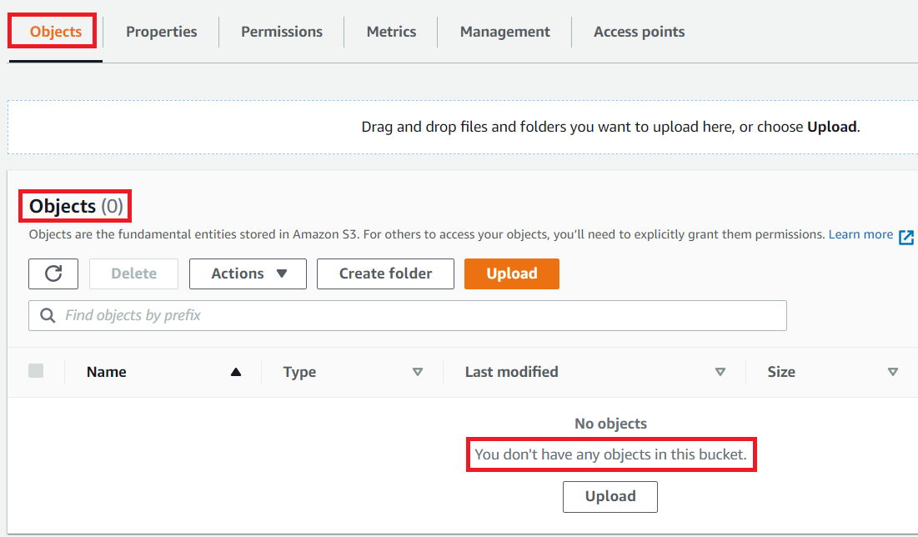

1. Upload sample.txt file present in zip file download the zip file from our [Download Me](https://labresources.whizlabs.com/d91ddd05430b3e2f755af1929cde16cf/task_21.zip) link.
2. To upload a file to our S3 bucket,
   * Click on the **Upload** button.
   * Click on the **Add files**button.
   * Browse for the file you want to upload.
   * Click on the **Upload** button.
   * You can watch the progress of the upload from within the transfer panel at the bottom of the screen. If it's a small file, you might not see the transfer. Once your file has been uploaded, it will be displayed in the bucket.

1. Now click on the **Close**button on the top right corner of the screen.
2. To **copy the ARN** of your S3 bucket, click on **Properties**tab and copy the ARN.
3. Make the bucket public with a Bucket Policy:
   * Click the **Permissions**tab to configure your bucket:
   * Scroll down to **Bucket policy** , click on **Edit** button on the Right side.
   * The policy editor will open.

* In the policy below, update your bucket ARN in the Resource key-value and copy the policy code.
* Paste the bucket policy into the **Bucket policy editor**.

|  |
| --- |
| {  "Id": "Policy1",  "Version": "2012-10-17",  "Statement": [  {  "Sid": "Stmt1",  "Action": [  "s3:GetObject"  ],  "Effect": "Allow",  "Resource": "replace-this-string-from-your-bucket-arn/*",  "Principal": "*"  }  ]  } |

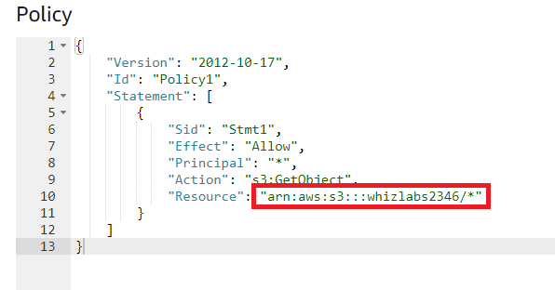

* Click on **Save Changes** button

1. Now again open the **Objects** tab, select the **object name** and click on **Copy URL.**

1. Open a new tab, paste the URL and you will get the below output.

Task 5: Upload different versions of the file

1. Now open the **sample.txt** file in your local text editor and update the file content as “***This is version 2***”.
2. Click on the **Upload** button.
3. Click on the **Add files** button.
4. Browse for the file you want to upload.
5. Click on the**Upload** button.
6. Now click on the **Close**button on the top right corner of the screen.
7. Once the file has been uploaded successfully, copy the **URL** and paste it into your browser.
8. You should see the latest version of the file you uploaded.

1. Similarly, again edit the **sample.txt** and update the content as "***This is version 3***".
2. Then upload the file into the bucket and check the output in the browser.

Task 6: Test the Versioning of the object

1. Open your S3 bucket, click on **Show versions**. You will get the list of versions available for your sample.txt.

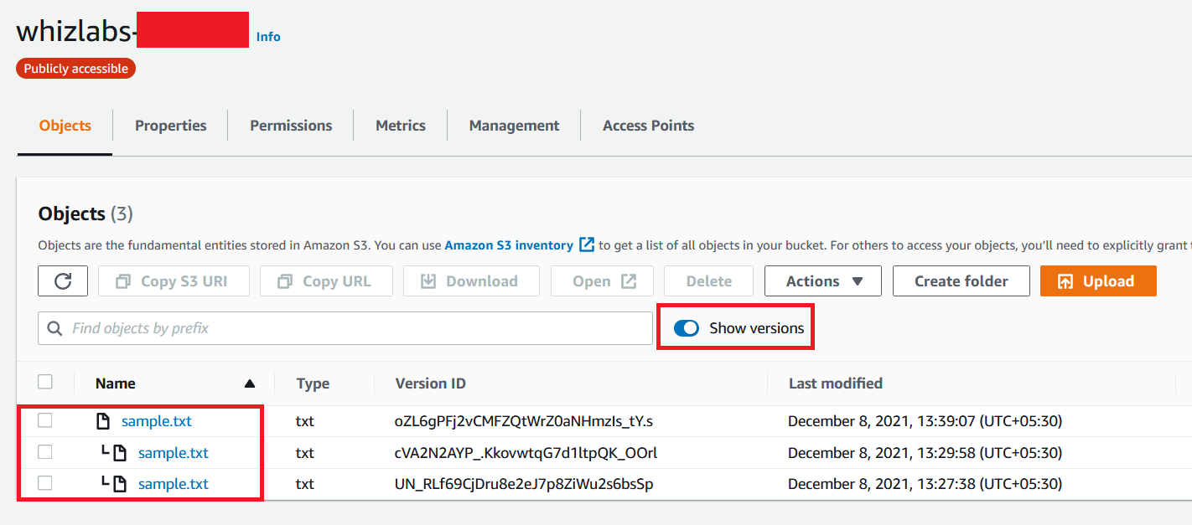

1. Now delete the first object and try to see the output in the browser.

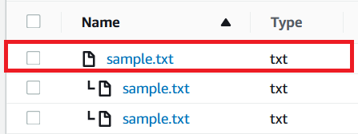

1. You will get the output as "**This is version 2**".